Unconventional Beauty

I shot the photograph below about a year and a half ago. My background is not in photography, but something about this photo has resonated with a lot of people. I’ve been thinking about our society’s concept of beauty lately and it seems appropriate to share the story of this today.
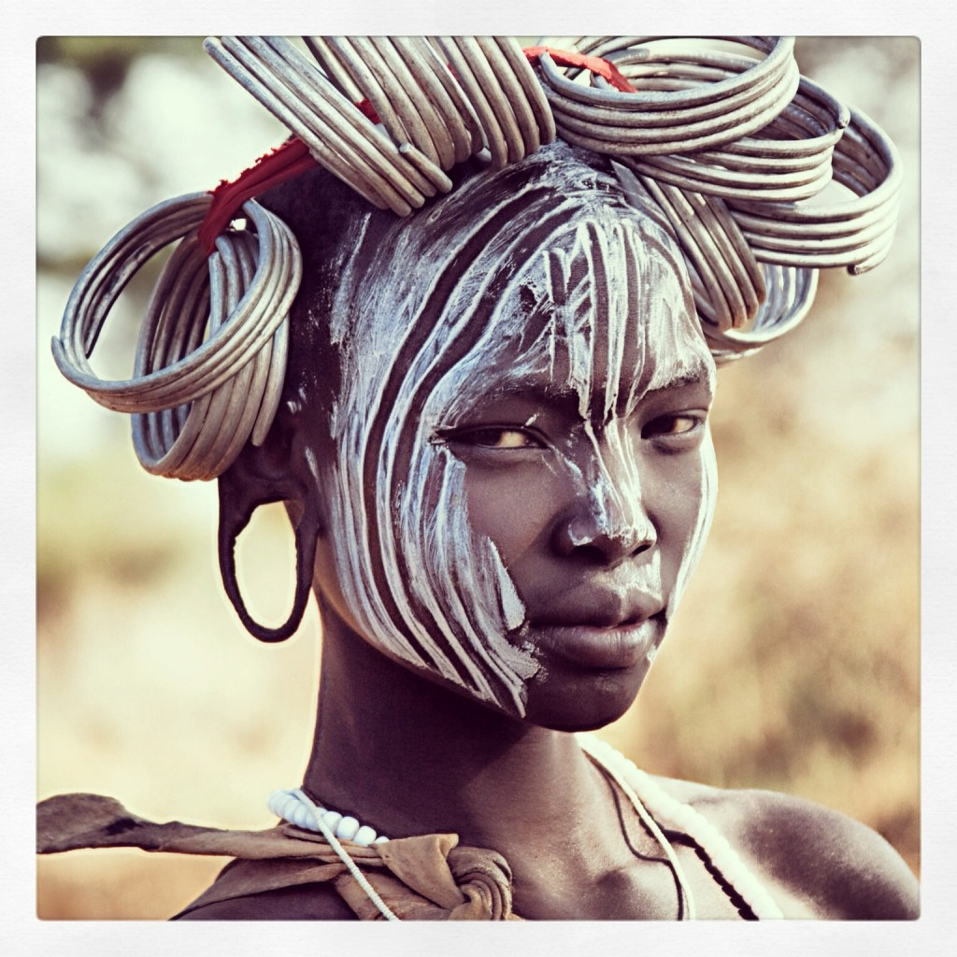
The woman in my photograph “Unconventional Beauty” is a member of the Mursi tribe in Southern Ethiopia. The Mursi tribe is one of the most famous and remote tribes in the world, predominantly known for the large clay lip plates their women wear.
Our guide told us the most common story regarding the history of this tribe: Centuries ago this tribe was known for its beautiful women and men from other tribes were notorious for interceding and attempting to marry them. The Mursi men decided that in order to keep their women to themselves they would make them as unattractive as possible, so they created clay lip plates and started stretching the women’s lower lips around these plates.
In order to accommodate the plates they cut a hole under the lower lip, which stretches open, leaving a gaping hole and a loose hanging lower lip when the plate is removed. They also remove the lower teeth so the plates don’t break when they wear them. The size of the plate is, of course, directly linked to the prestige and perceived beauty of the woman wearing it. I found the plates themselves to be beautiful, but the women were so disfigured it saddened me. I noticed something in the eyes of women wearing the lip plates that I had not seen in other African tribes. To me, it was almost as if these women were pleading for some form of validation. I expected the Mursi women to be strong and brash and invincible, but I saw first-hand that they want what all women want, someone to look in their eyes and say,
You are beautiful.
The desire for acceptance and acknowledgment is universal.
I was drawn to the woman in my photograph for many reasons. I actually shot her portrait three separate times that day. It impressed me that she has the obvious and undeniable courage to stand up to the men in her tribe and refuse to pierce her lip. That kind of bravery is heroic in a male dominated culture. She may be the voice of a new generation in her tribe, a generation of women who question conventional traditions and who make choices based on the future they desire, instead of the future society expects for them. In American culture this Mursi woman would be considered unbelievably beautiful, but in hers, she may be considered hideous because she does not wear a lip plate. I saw courage, confidence and vulnerability in her as I photographed her. She moved me. I believe that whether someone comes from a tribe in Africa or the projects in Compton, every person has the fundamental right to determine his or her own path in this life. I have this photo hanging on my wall as a reminder of that fact.

